Lab10 Noisy transcription

Zhuoyang Chen 11/15/2019

**1. Model**

A stochastic version of mRNA dynamics, with its deterministic version described before as:

$$M=k_{r}-δ_{r}M$$

$k_{r}$ is a constant production rate of mRNA and $δ_{r}$ is the degradation rate proportional to mRNA abundance.

In the program, a1**=**kranda2**=**gr**\***X**(**j) are the two propensities for production and degradation. asum**=**a1**+**a2and t**(**j**)=**t**(**j**-**1**)-**log**(**rand**(**1**))/**asumis to update the current time step according to the random number and the sum of the propensities. Since rand(1) would produce random number from 0 to 1 evenly, the value of log(rand(1)) would always be less than 0. Divided the log by asum is to reduce the time stepsize if the sum of propensities is large.

mu**=**rand**(**1**);**

**if** mu **<** a1**/**asum

X**(**j**)=**X**(**j**-**1**)+**1**;**

**else**

X**(**j**)=**max**(**X**(**j**-**1**)-**1**,**0**);**

**end**

The random number mu here range from 0 to 1, represents a probability threshold and decides what change would happen to the system.

**2. Baseline Run**

Time series data of mRNA number

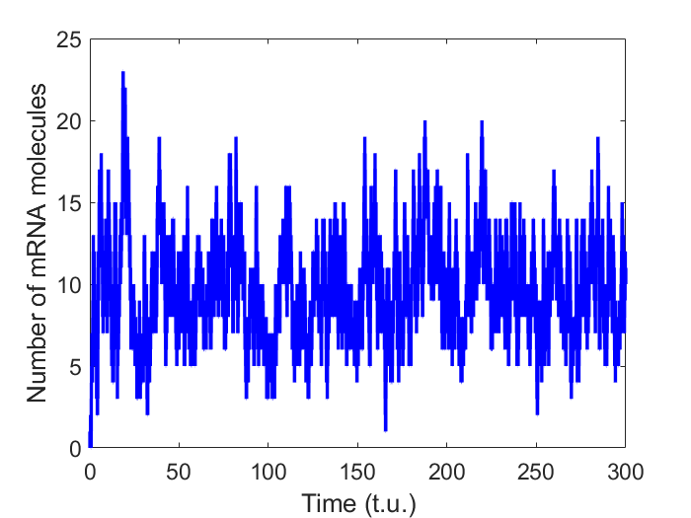

mRNA number is fluctuating around its steady state.

Histogram of mRNA number distribution

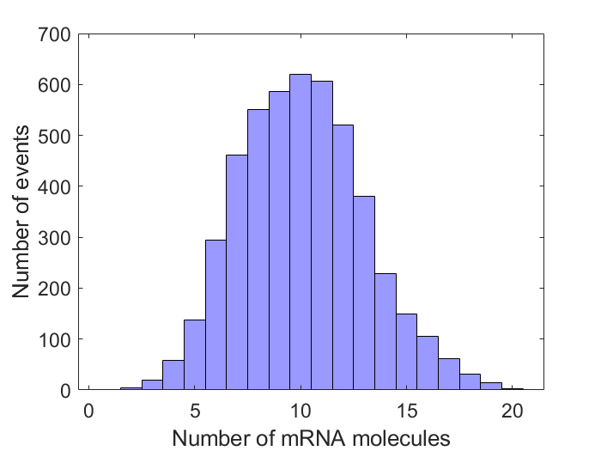

mRNA number follows a normal distribution as histogram is bell-shape. Mean of mRNA number after a transient time of 1000 is 10.44, using mean(X(1000:end))

Deterministic model comparison

Using ode45 function in Matlab to simulate the mRNA dynamics with deterministic system.

Result is shown as below:

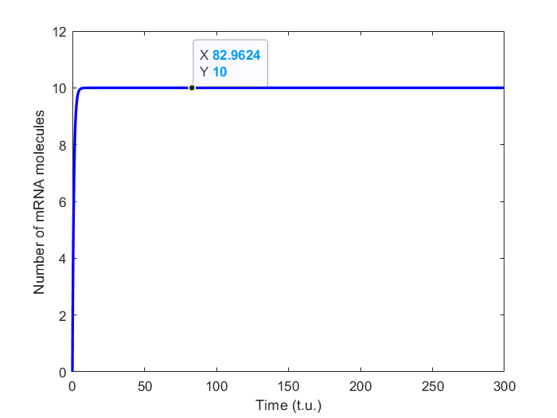

Compared to the stochastic system, it also reaches the steady state very quickly, but no fluctuation can be seen in the deterministic model. The fixed point is 10, which means the mean mRNA abundance (10.44) calculated from a stochastic model is a little larger than its corresponding deterministic model. That is because in stochastic model, all the change depends on random number, and there is less certainty of getting the fixed point 10. It may also get a mean value less than 10.

**3. Rate variations**

a. **Varying kr**

Keeping δr = 1.0 unchanged, scaling kr from 1.0 to 10, calculate the mean and coefficient of variant after transient for each case. Notice that when changing kr, the asum = kr + gr * X (i) will change too, giving a different simulating data points during examining various kr. The transient time 1000 could not be applied when data points are less than 1000 at low kr. To solve this, I re-defined the transient time as the first 20% of the total data points. Results are shown as below.

Histograms of mRNA number when kr varying from 1.0 to 10

kr = 1.0 kr = 2.0 kr = 3.0 kr = 4.0

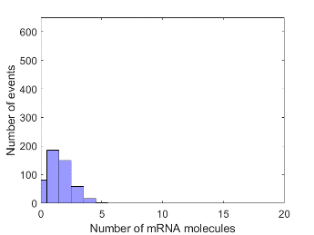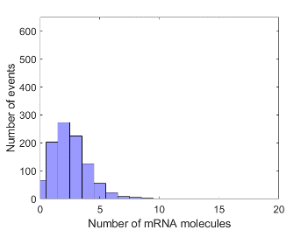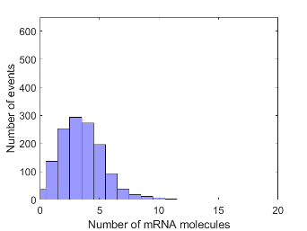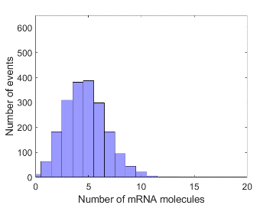

kr = 5.0 kr = 6.0 kr = 7.0 kr = 8.0

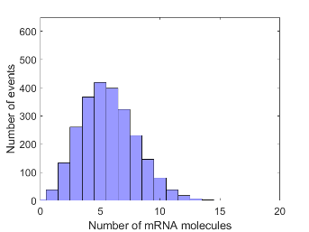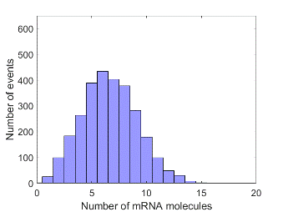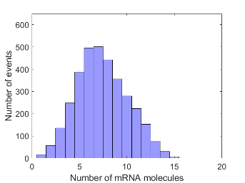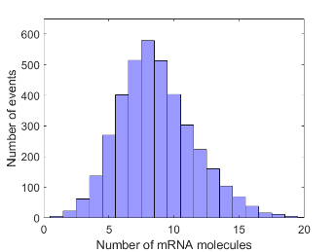

kr = 9.0 kr = 10

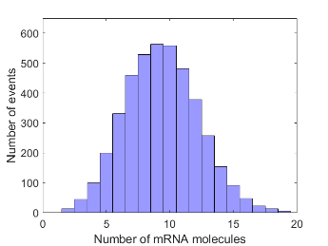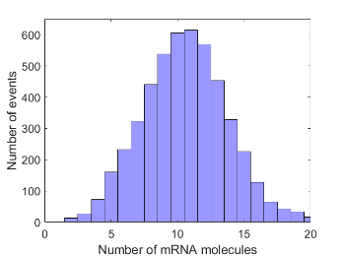

We can see from the above that as kr getting larger, the there would be more time steps in the pre-set 300 simulation duration and more data points are collected, as the total area of histogram becomes larger and larger. And the distribution is shifting right, meaning the mean of mRNA number is getting larger. Theoretically speaking, the peak should at the value of kr, but not necessary in the simulation, because everything happens by chance (eg. kr = 4 and 9).

Mean of mRNA number with varying kr

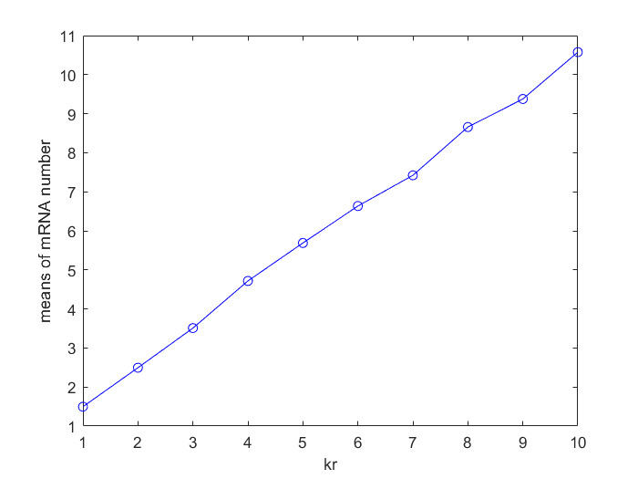

As kr getting larger, the mean of mRNA number in the stochasitc model is getting larger, relative higher than their deterministic fixed point values.

Coefficient of variant of mRNA number with varying kr

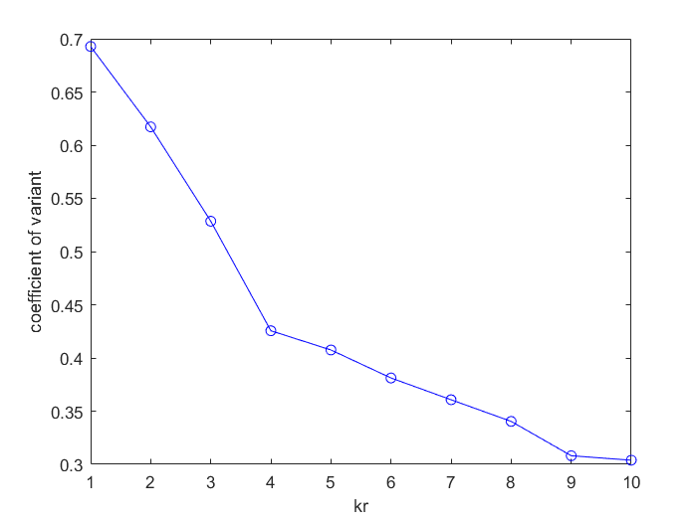

As kr getting larger, coefficient of variant is decreasing, due to a more stable system and more data collected.

b. varying δr

Keepiing kr = 10 unchanged, scaling δr from 1.0 to 5.0 with increment of 1.0. Results shown as below.

Histograms of mRNA number when gr varying from 1.0 to 5.0

gr = 1.0 gr = 2.0 gr = 3.0

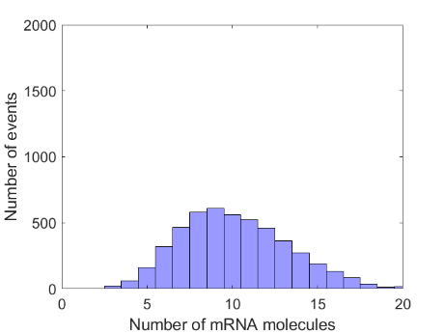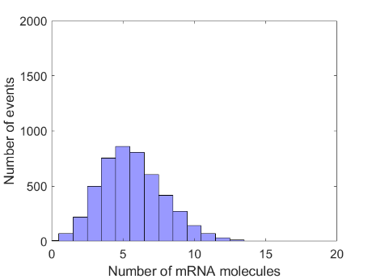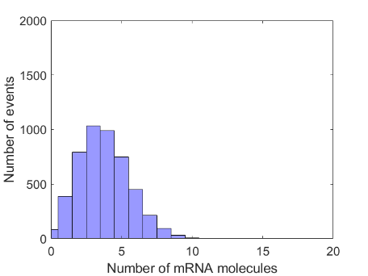

gr = 4.0 gr = 5.0

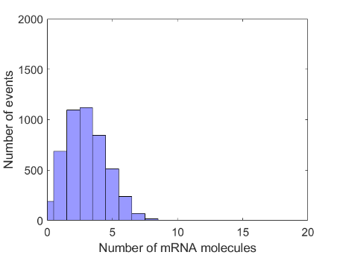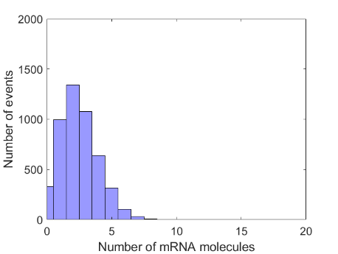

As gr getting larger, the distribution of mRNA number is shifting left, meaning a lower amount of mRNA at steady state. The total amount of data point is nearly unchanged during the varying process, because when gr is larger, there is more likely to get less mRNA, making the propensity of a2**=**gr**\***X**(**j) smaller, canceling the increment of gr.

Mean of mRNA number with varying gr

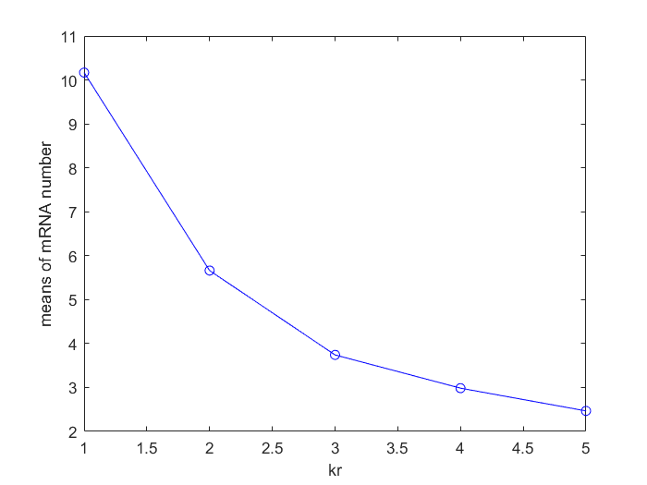

Coefficient of variant of mRNA number with varying gr

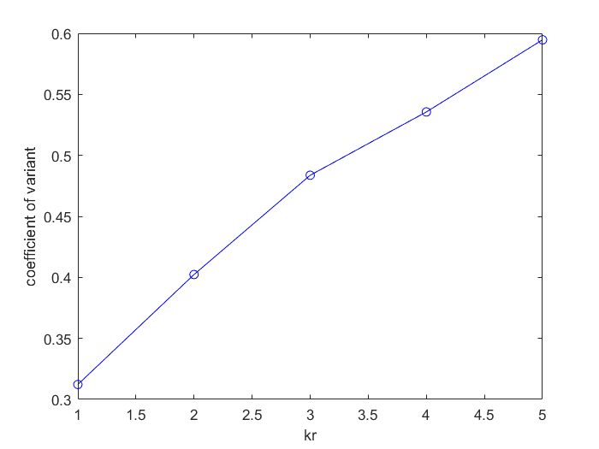

As gr getting larger, the mean of mRNA number is decreasing due to increasing degradation rate, and the mean number is still slightly higher than their fixed point values in deterministic model. The coefficient of variant is getting larger, due to a less stable system.

**4. Bursty transcription**

Reducing the kr from 10 to 2 by a factor of 5, but when the random number mu is less than the transcription event threshold, transcription occurs and 5 copies of mRNA would be added instead of 1 to the current amount of mRNA. Results are shown as following:

Time series data of mRNA number Distribution of mRNA number

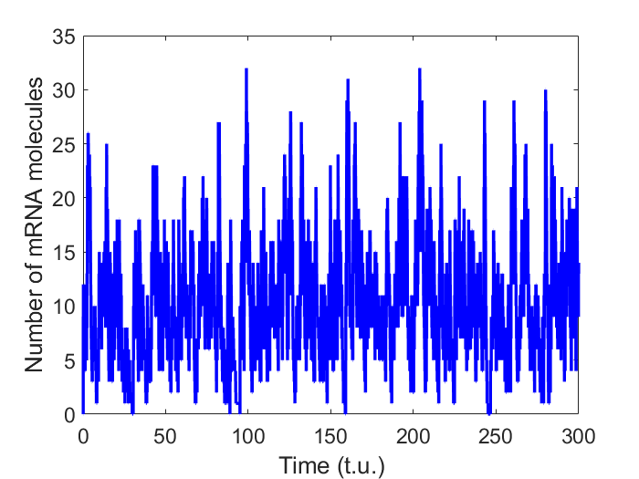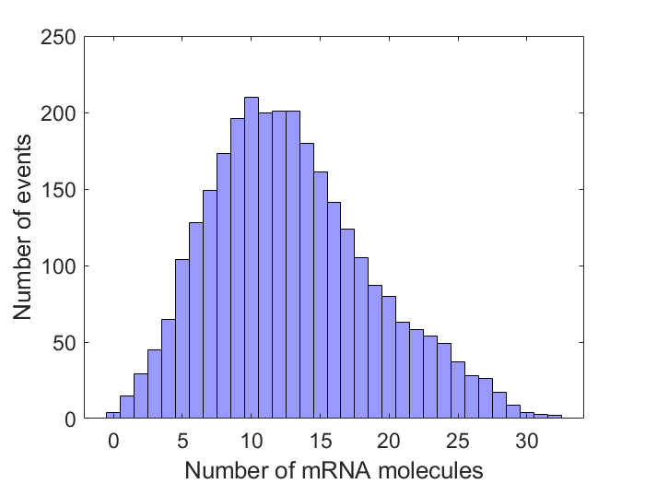

From the above, we can see that the system is less stable, much fluctuating now in the bursty transcription case. The range of possible mRNA number extend to [0, 32] from the original [0, 20]. Still a peak of 10 could be seen, but a wide platform rather than a narrow peak could be better described the figure. After calculation, the mean after transient is 12.92, much higher than 10, and a coefficient of variant is 5. 90, a 8.4 fold of the initial 0.7, indicating a less stable system.